VPN Setup

Step 1: Visit <https://vpn.outlinesystemsindia.com> and login using your domain credentials.

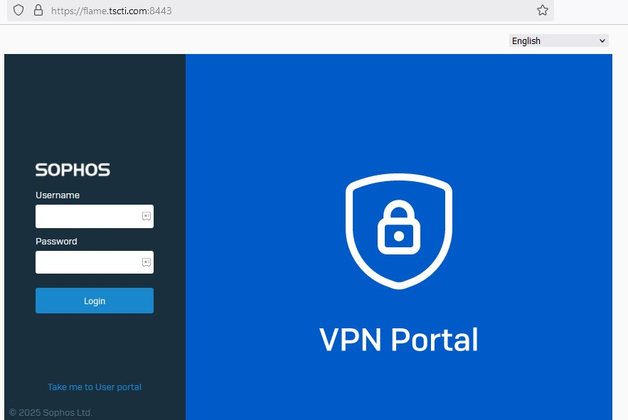

Step 2: Download the Sophos Connect client

Under **Sophos Connect client**, click **Download for Windows**.

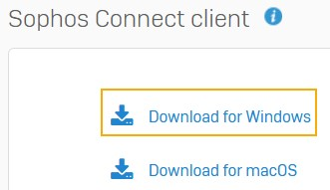

Click the downloaded file to install the **Sophos Connect** client on your device.

Step 3: Now Under **VPN configuration**, click **Download configuration for Windows, macOS, Linux**.

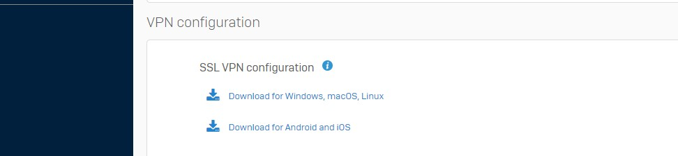

This downloads a .ovpn file.

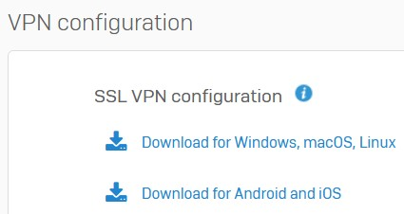

**Note**

You can see the **SSL VPN configuration** files for download only if your administrator has configured a remote access SSL VPN policy for you.

You can see the client on your desktop. Double-click the client.

You can then see it in the tray in the lower-right corner for Windows and the upper-right corner for macOS devices.



Step 4: Import the configuration file to the client

Click the **Sophos Connect** client on your endpoint and click **Import connection**.

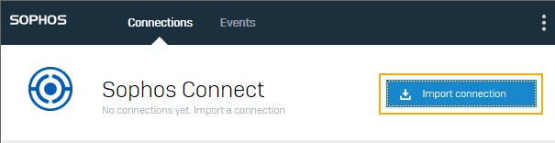

Select the .ovpn configuration file you've downloaded.

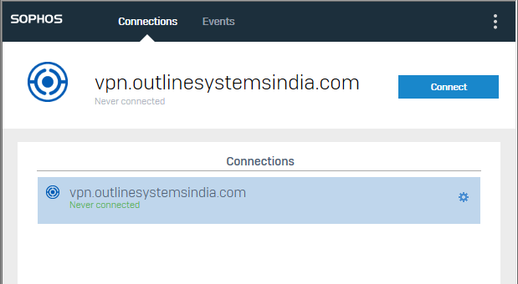

Click **Connect** to sign in.

Enter your domain username and password and Click **Sign in**.

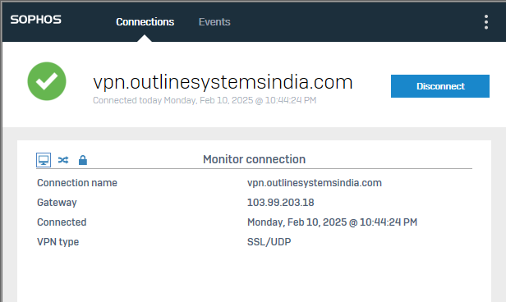

This establishes the remote access SSL VPN connection.